Lab 08

MOSFET Characteristics
Name: Haider, Sualeh | Student ID: 10303, 10270

Objective
To investigate the characteristics of MOSFET (Metal Oxide Semiconductor Field Effect Transistor) through its characteristic curves

Introduction to MOSFETs
MOSFETs (Metal-Oxide-Semiconductor Field-Effect Transistors) are the type of FETs (field-effect transistors) in which the metal gate electrode is separated from the semiconductor by an insulator and therefore, also known as Insulated Gate Field Effect Transistors (IGFET). Unlike the current-controlled bipolar device (BJT), which requires base current to allow the current to flow in the collector, the MOSFET device is a voltage-controlled unipolar device because the conduction is controlled by voltage and it uses only the majority carriers in conduction. MOSFETs surpass all other devices in switching speed, where switching speeds can exceed a few megahertz. MOSFETs can be mainly categorized as enhancement type and depletion type.

Pre-Lab Task

Task 1:
- Mention various types of MOSFET and applications of MOS.
- Construct complete structure of Enhancement and Depletion type MOSFETs
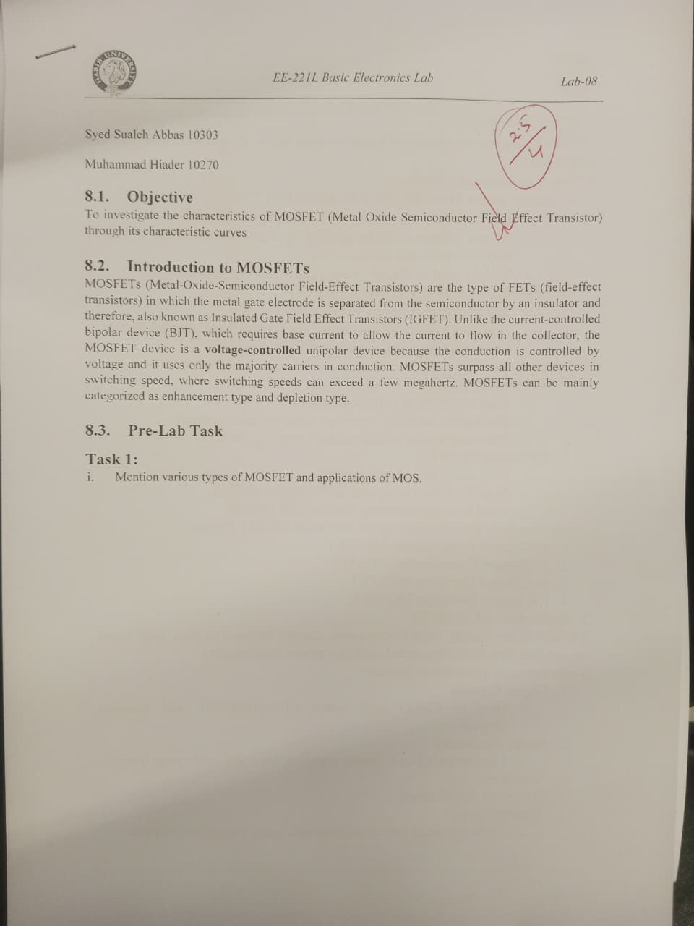

Structure
The basic structure of MOSFET is shown in Figure 1. The structure consists of three layers: the metal gate electrode, the insulating oxide layer (SiO₂) and the bulk semiconductor. It is an enhancement type n-channel MOSFET. It consists of a lightly doped p-type substrate in which two heavily doped n-regions are formed at the two ends by the process of diffusion. The n-channel and p-channel enhancement type MOSFETs are represented by the symbols given in Figure 1 (b) and (c). It has three terminals; drain (D), gate (G) and source(S). The body (also called substrate) and source are internally short.
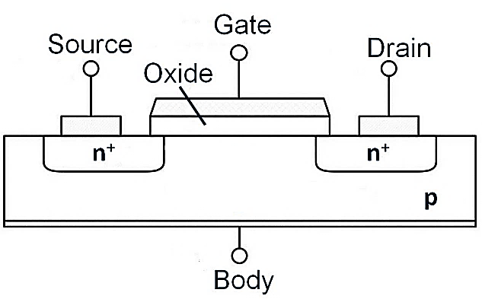  - n-MOSFET structure | 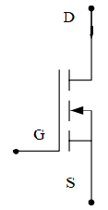  - n-MOSFET | 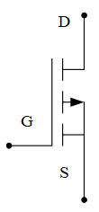  - p-MOSFET
Figure 1: Structure and symbol of MOSFET

Regions of Operation
Initially for the enhancement type MOSFETs, the channel between the source and drain terminals required for flow of current is non-existent. This channel is created or “enhanced” by the minority charge carriers of the substrate under the influence of field created by the voltage applied gate terminal V_{G} when it reaches a certain threshold called threshold voltage V_{th}. Now, if voltage is applied between drain and source terminals V_{DS}, flow of current starts through the channel. This current I_{D} increases linearly as V_{DS} is increased before saturation occurs. At saturation, the phenomenon of channel pinch-off starts and after that if V_{DS} is further increased, the current I_{D} becomes almost constant. Therefore, the MOSFET operates in the following three regions given in Table 1.
Table 1: Regions of operation of MOSFET
Region of Operation | Condition | Description
Cut-off Region | n-channel:  p-channel: | The device operates in off-state since channel is not induced.
Triode Region | n-channel: and  p-channel: and | The channel is continuous with no pinch-off, resulting in drain current proportional to the channel resistance.
Saturation Region | n-channel: and  p-channel: and | The channel pinches off resulting in constant drain current.

In this lab, we will investigate the characteristics of the 2N7000 n-channel enhancement type MOSFET. The datasheet can be accessed using this link.

Task 2: To determine the threshold voltage of MOSFET 2N7000
- Implement the circuit shown in Figure 2 using the 2N7000/Design Cache MOSFET model in PSpice. Model number 2N7000/NPX MOSFET
Figure 2: Voltage applied at drain and gate terminals of 2N7000 MOSFET
- To determine the threshold voltage of MOSFET, first we apply fixed voltage across drain the to source terminal and then gradually increase the gate voltage. The gate to source voltage at which current starts flowing from drain to source will be threshold voltage V_{th}.
- Set V_{dd} at 10V. Perform DC sweep to vary the voltage of source connected at the gate terminal from 0 to 5 V in steps of 0.01V. In other words, Vg is the primary sweep variable.
- Obtain plot of drain current I_{D} as a function of V_{GS}. Determine the threshold voltage i.e. the voltage after which conduction starts. Add capture of the obtained plot.
THRESHOLD VOLTAGE= 2.214V
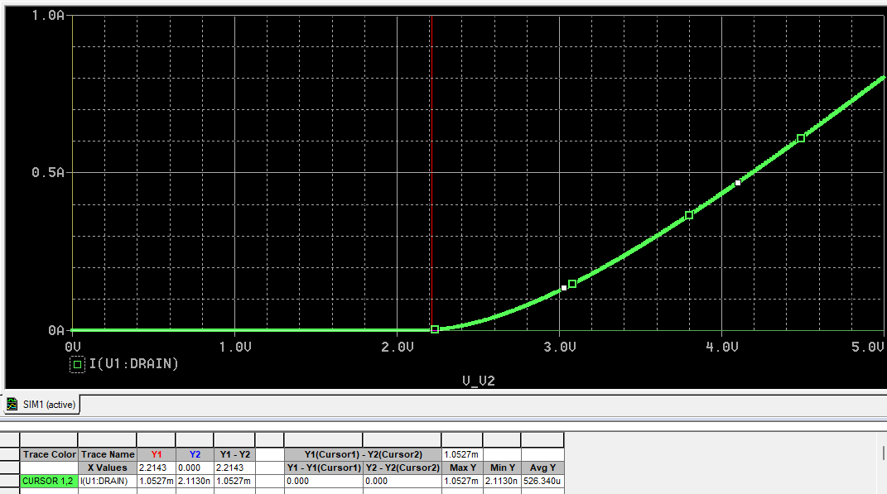

Task 3: To obtain the drain characteristic curve of MOSFET 2N7000
Drain characteristic curve of MOSFET is a plot of the drain current as a function of drain-source voltage for given gate-source voltage.
- Create a new simulation profile. For the circuit shown in Figure 2, now set V_{GS} equal to 3V and sweep the drain-to-source voltage from 0 to 10V in step size of 0.01.
- Obtain drain characteristic curve and mention the gate-to-source voltage for which the curve is obtained.
- Keeping in mind the determined threshold voltage from Task 1 and the conditions given in Table 1, determine the modes of operation of MOSFET and add text labels on the plot. By putting value of threshold voltage and applied gate voltage, show which condition is satisfied in which region.
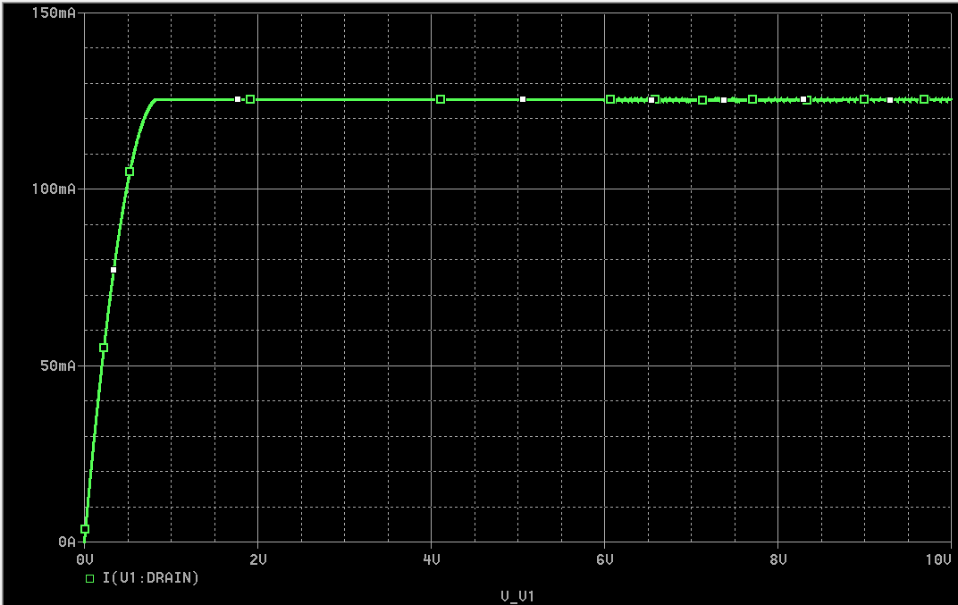
The region in white box is called the ohmic region, after that the constant straight line is called the saturation region.
SATURATION: Vds >= Vgs – Vgs(th)
OHMIC REGION: Vds<Vgs-Vgs(th)

Task 4: To investigate the effect of gate voltage on the drain characteristics of MOSFET 2N7000
To investigate the effect of gate-to-source voltage, one can obtain drain characteristic curves for different values of gate-to-source voltage.
- Modify the DC Sweep Analysis settings to include secondary sweep for gate-to-source voltage. The gate-to-source voltage is to be varied from 2 to 5V in steps of 1V.
- Obtain drain current curve as a function of drain-to-source voltage. It should show a different curve for each gate voltage.
- Identify and mention corresponding V_{GS} for each curve. Also, mention the cut-off region here. Add capture of the plot.

According to the simulation plot provided in the manual, the different curves represent the drain current (ID) for varying gate-to-source voltages (Vgs).
- Corresponding Vgs for each curve:
  - Top Curve: Vgs = 5V
  - Middle Curve: Vgs = 4V.
  - Bottom Curve: Vgs = 3V.
- Cut-off Region: This is the region where Vgs < Vth (Threshold Voltage). In this state, the drain current Id is approximately 0A regardless of the value of Vds

- Analyze the impact of gate-to-source voltage on the curves and drain current.
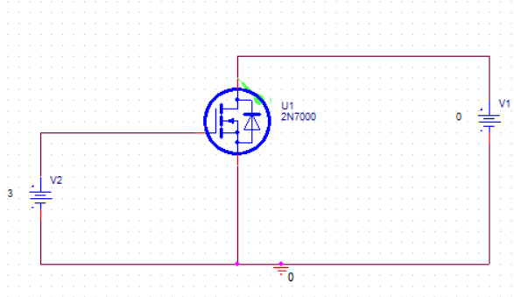
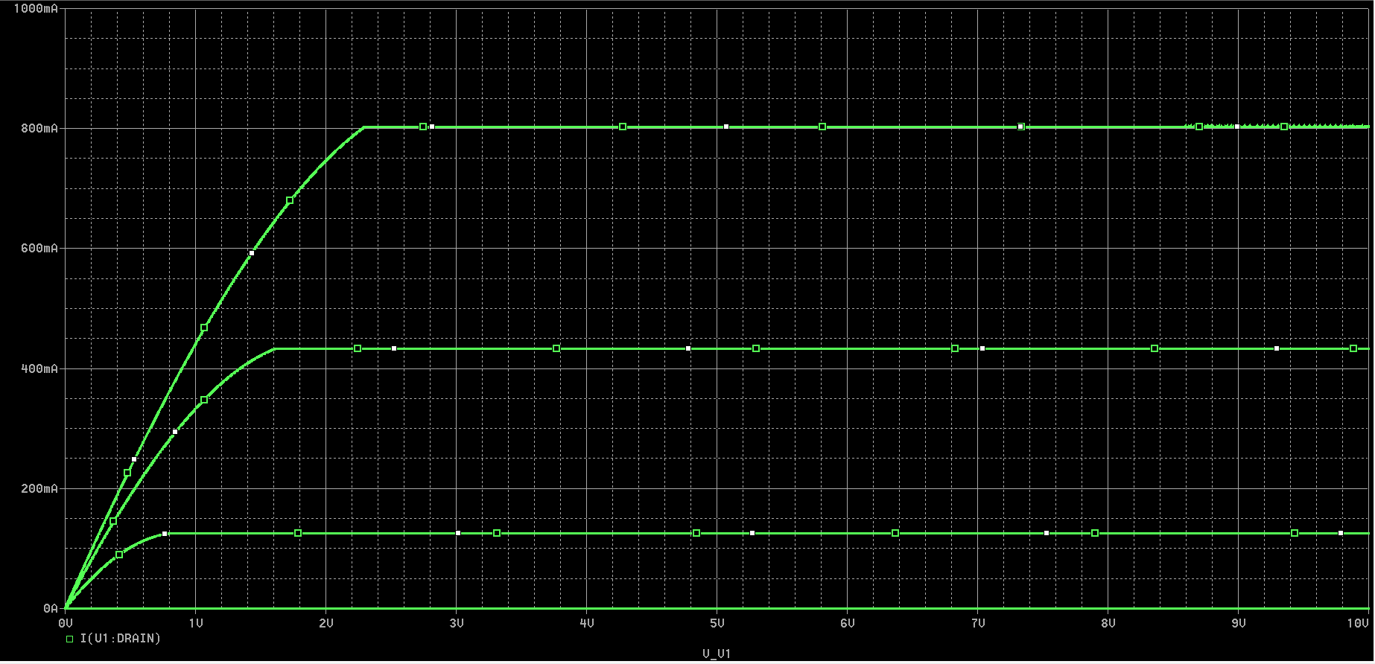

The impact of gate-to-source voltage (Vgs) on the drain characteristics is as follows:
- On Drain Current ($I_D$): As Vgs increases, the drain current Id also increases significantly. This is because a higher gate voltage creates a deeper and more conductive channel, allowing more charge carriers to flow from the source to the drain.
- On the Saturation Point: Increasing Vgs shifts the onset of the saturation region to higher values of Vds. This occurs because the saturation condition Vds >= Vgs - Vth requires a larger Vds to achieve pinch-off when Vgs is higher
- On Ohmic (Triode) Resistance: In the ohmic region (low Vds), a higher Vgs results in a steeper slope for the Id - Vds curve. This indicates that the channel resistance (rd) decreases as Vgs increases

Task 5: To determine trans-conductance g_{m} of MOSFET 2N7000
The trans-conductance g_{m} describes the effect the gate has on the conductivity of the MOSFET at a certain operating point. The trans-conductance of a MOSFET in the linear region is given as:
- From the I_{D}-V_{GS} curve of Task 2, determine trans-conductance. Use cursors to measure the small change in current for small change in voltage (around 100-200mV).

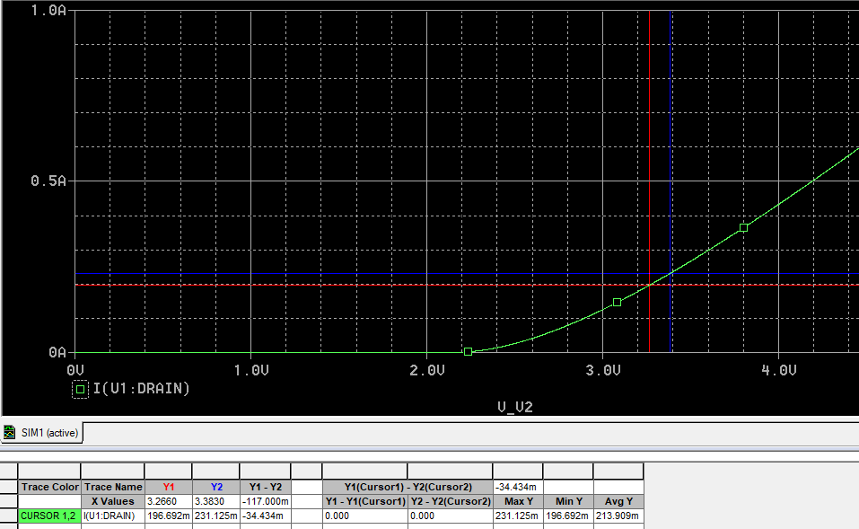

Table 2: Data collection to determine trans-conductance
Change in current: $∆$I_{D} | 34.43 mA
Change in current: $∆$V_{GS} | 117 mV
Trans-conductance: g_{m} | 0.294

Task 6: To obtain the threshold voltage of MOSFET 2N7000 through hardware implementation.
- Using a 10 kΩ potentiometer, as indicated by the circuit below, determine the MOSFET’s threshold voltage, V_{TH}, by monitoring the drain voltage V_{DS,} as you vary the gate voltage V_{G}, using the potentiometer. It is recommended to adjust the threshold voltage to be that voltage for which the drain current reaches 0.1 mA.
- Measure the actual resistance of drain resistor R_{D} using a digital multimeter and record the reading.
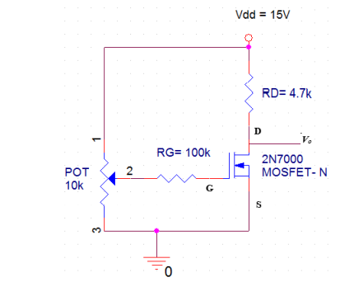
Figure 3: Common Source 2N7000 MOSFET Configuration

- Record your readings in the below table.
Table 3: MOSFET Input Characteristic Measurement
Drain Resistor: R_{D} | 4.64k
Drain Current: I_{D} | 102.75uA
Gate Voltage: V_{GS} | 1.357V
Threshold Voltage: V_{TH} | 1.357V
Drain Voltage: V_{DS} | 14.47V
- According to the readings in Table 3, what is the mode of the operation of the MOSFET? Justify it through the values of V_{TH}, V_{GS} and V_{DS}.
Based on the recorded values in Table 3, the MOSFET is operating in the saturation region. Although the gate-to-source voltage (Vgs) of 1.37V is exactly equal to the threshold voltage (Vth), the device is technically in the "on" state because the condition Vgs >= Vth is met. This is further confirmed by the drain current (Id) of 101.28 µA, which meets the lab's specific recommendation to treat the threshold as the point where conduction reaches 0.1 mA. When checking the region of operation, the overdrive voltage (Vgs - Vth) is 0V. Since the measured drain-to-source voltage (Vds) of 14.3V is significantly greater than this 0V overdrive, the saturation condition Vds >= Vgs - Vth is clearly satisfied.

Task 7: To investigate the effect of gate voltage on the drain characteristics of MOSFET 2N7000 by hardware implementation.
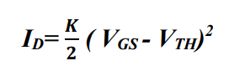
The drain current of the mosfet in the saturation region can be calculated by the equation given below.

Where, K is known as the process transconductance parameter and equals to:
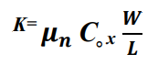
- Using the same circuit as shown in Figure 3, increase the gate voltage so that it is 0.25 volts above threshold. Calculate the drain current by measuring the voltage drop across the drain resistor R_{D}. Note down the calculated values in Table 04.
- Now determine the value of K using the above equations.
$$K = 0.003288 A/V^{2}$$

- Using the values of V_{TH} and K determined above for your transistor, calculate the value of V_{GS} required for a drain current I_{D}= 2mA using the given formula. Use a source resistor R_{S}= 2.2 kΩ to find values of R_{G1} and R_{G2} required to produce this gate-source voltage (since there is a sizeable leakage current with this set-up recommended value of R_{G1} is 20 kΩ) while using the below circuit. Show calculations.
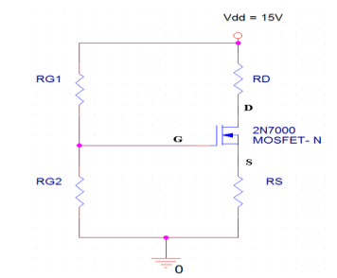
Figure 4: Voltage Divider Bias 2N7000 MOSFET Configuration
- Construct the bias circuit above using the available resistor values that best match your design (i.e., those that give the closest value of V_{GS})
- Measure the resistances, gate and drain voltages, and the drain current and fill them in the below table.
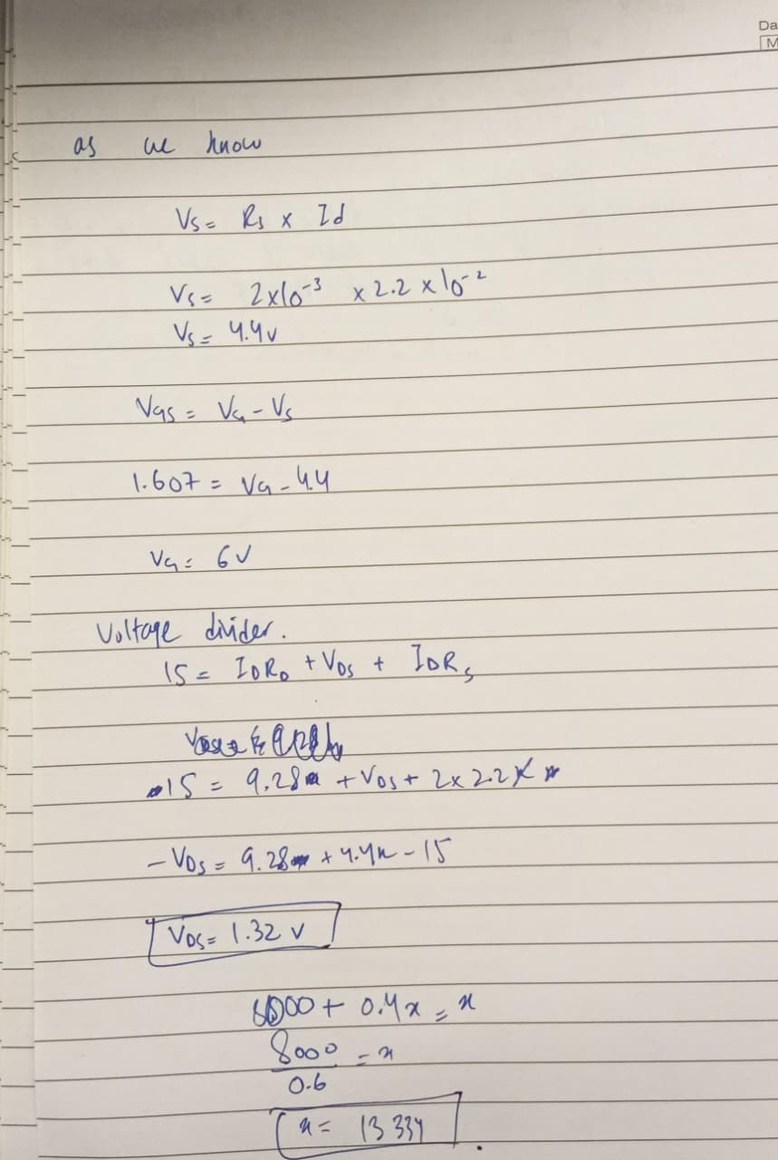
Table 4: Data collection
 | Calculated Results | Measured Results
V_{GS} | Vth + 0.25V= 1.607 | 1.604
V_{DS} | 1.32v | 1.41
I_{D} | 1.808mA | 1.55mA
R_{G1}, R_{G2}, R_{S} | 20k,13.33k , 2.2k | 19.8k, 12.9k,

- Now, calculate the transconductance, gm of given transistor under biased conditions using the below formula:

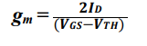
g_{m} = 0.0144

Task 8: To determine the channel resistance r_{d} of MOSFET 2N7000
In triode region, you can see that the slope of I_{D}-V_{DS} curve changes with change in V_{GS}. This slope determines channel resistance r_{d}. It is the ratio of small change in drain to source voltage (ΔV_{DS}) to the corresponding change in drain current (ΔI_{D}) for a constant V_{GS}.
- Find this channel resistance for different values of V_{GS}, from the characteristic curves of Task 4. Use cursors and measure it at the center of triode region in each curve. Let, the small change in voltage be 0.2V.
- Fill in Table 5.

3 VOLTS:
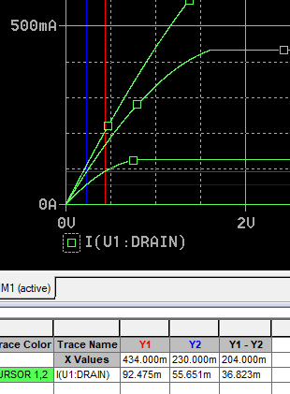
4 VOLTS:
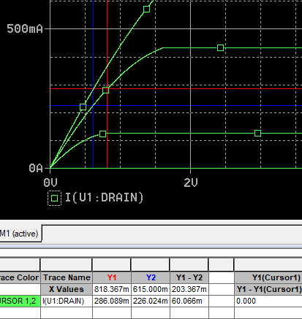

5 VOLTS:
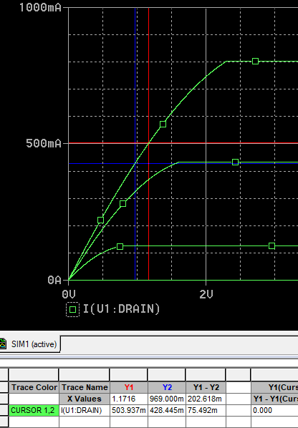
Table 5: Data collection for determination of channel resistance
V_{GS} | 3V | 4V | 5V
Change in current: $∆$I_{D} | 36.82m | 60.06m | 75.5m
Change in current: $∆$V_{DS} | 0.204 | 0.203 | 202.61m
Channel resistance: r_{d} | 5.54 | 3.37 | 2.67

- Analyze the impact of gate-to-source voltage on this channel resistance in triode region. What will be the value of this channel resistance in saturation region for the ideal behavior of MOSFETs as obtained in simulation?
In the triode region, the channel resistance rd is inversely proportional to the gate-to-source voltage Vgs, meaning that as Vgs increases, the channel resistance decreases. This occurs because a higher gate voltage attracts more charge carriers, creating a wider and more conductive channel. , VGS directly controls the depth of the channel, the greater the overdrive voltage (Vgs − Vth), the lower the channel resistance.
For the ideal behavior of a MOSFET in the saturation region, as obtained in your simulations, the drain current Id remains constant regardless of changes in Vds. Because the slope of the Id-Vds curve is zero in this region, the ideal channel resistance rd which is the ratio of the change in voltage to the change in current becomes effectively infinite

Assessment Rubric
Lab 08
MOSFET Characteristics
Name: | Student ID:

Points Distribution

Task No. | LR1/2  Circuit /Simulation  24 | LR 4  Data Collection  22 | LR 5  Plots  20 | LR 6  Calculation  10 | LR 10  Analysis  20
Task 1 | - | - | - | - | /4
Task 2 | /4 | /2 | /4 | - | -
Task 3 | /6 | /4 | /8 | - | /4
Task 4 | /6 | - | /8 | - | /6
Task 5 | - | /4 | - | /2 | -
Task 6 | /4 | /4 | - | /2 | /2
Task 7 | /4 | /4 | - | /4 | -
Task 8 | - | /4 | - | /2 | /4
CLO Mapped | CLO 3 | CLO 1 | CLO 3 | CLO 1 | CLO 1
 | /24 | /22 | /20 | /10 | /20

Affective Domain Rubric |  | Points | CLO Mapped
AR 4 | Report Submission | /4 | CLO 4

CLO – (LDL) | Total Points | Points Obtained
CLO1– (Psy-3) | 52
CLO3 – (Psy-4) | 44
CLO4 – (Aff-3) | 04
Total | 100

For description of different levels of the mapped rubrics, please refer the provided Lab Evaluation Assessment Rubrics and Affective Domain Assessment Rubrics.

